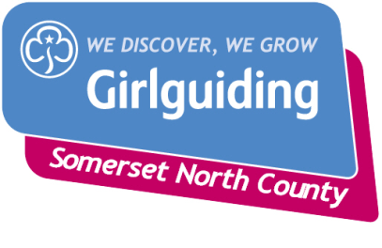

Request for Financial Assistance with the 2023 Annual Subscription.

Unit …………………………………………………………………………………………………………………………………………

Leader …………………………………………………………………. Membership Number ……………..……...…..

I am requesting help with the Annual Subscription on behalf of ………… girls and ………...Leaders because:

Please supply the following information as supporting evidence:

- How much are your current Unit funds? Bank ………. Cash ………….

- How much were your Unit subs in 2022? £……. per girl

- How much did you receive £……..?

- Do you claim Gift Aid? Y/N
If no, we can help and support you in claiming it.

- Did you submit your 2021 accounts to your District Commissioner? Y/N

Please send this form to your DC.

………………………………………………. District can/cannot provide full/partial financial support.

If full/partial financial help cannot be provided please explain why and then send this form to your Division Commissioner

District Commissioner Signature …………………………………………………………… Date ……………………

……………………………………… Division can/cannot provide full/partial financial support.

If full/partial financial help cannot be provided please explain why and then send this form to the Chair of the Finance Adviser: finance@girlguidingsomersetnorth.org.uk

Division Commissioner’s signature …………………………………………….. Date ……………………………….

